CSE546 Group Project 1 Report
Heet Punjawat - hpunjawa@asu.edu
Omkar Pisal - opisal@asu.edu
Shivanjay Wagh - swagh5@asu.edu

1. Problem statement
The project aims to develop an elastic cloud-based application that offers image recognition service to users by leveraging deep learning models. The application will automatically scale-in and scale-out, on-demand, using AWS Iaas resources. The app will take images from users and return top 1 recognition results according to the deep learning model provided to us. The workload generator is used to create concurrent requests to test the application. All inputs and outputs will be stored in S3 buckets for persistence, and automatically scale using CloudWatch and SQS queues.
It is important to solve this problem because it teaches us how to basically build an elastic cloud application. Elastic applications are becoming popular nowadays, because they can handle fluctuating user demands without incurring the cost of maintaining fixed infrastructure. It gives us an opportunity to apply knowledge of cloud computing, deep learning, and software engineering to solve real world problems and gain some practical experience.

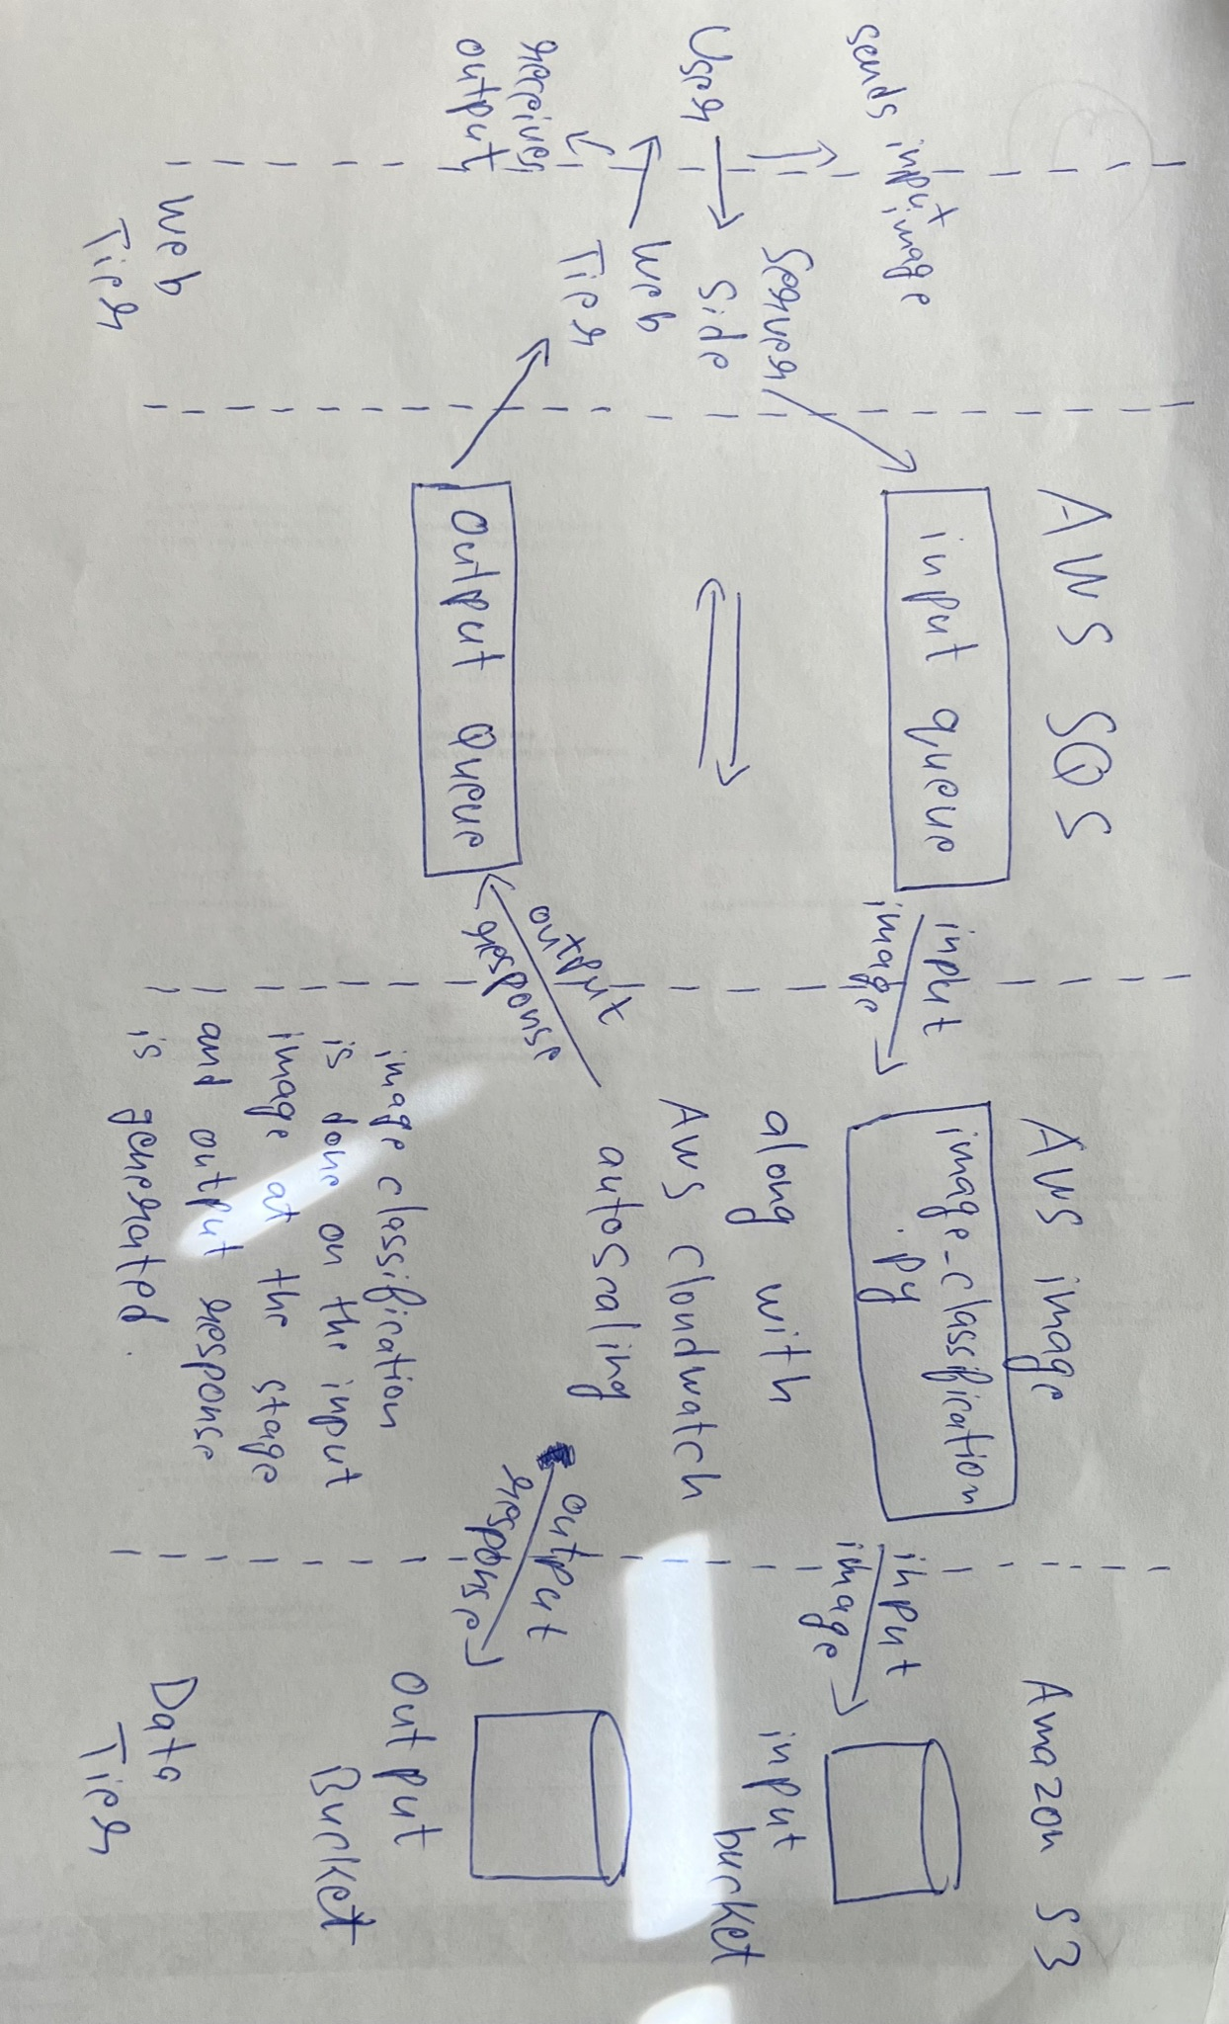
2. Design and implementation

2.1 Architecture

Web tier: This component is responsible for handling user requests and responses. The POST request contains the uploaded images by the user and uses AWS SDK to send the image to an SQS queue for processing.

SQS queues: AWS SQS queue is a message queuing service. SQS processes the images uploaded by the user, handles multiple images sent by the user. An EC2 instance monitors the queue and processes images as they arrive. Once the processes is done, the results are sent to the user by an output queue.

EC2 instance and AMI: Amazon Elastic Compute Cloud is a service that provides resizable compute capacity in the cloud. Here, EC2 is used to process images uploaded to the queue by the user. The EC2 instance runs an Amazon Machine Image (AMI) provided to us by Dr. Deng, which contains the pre-trained image classification model, and sends the results back to the user.

S3 Buckets: Amazon Simple Storage Service is a scalable, high-speed service designed for online backup and archiving of data and application programs. Here, S3 is used to store the input images sent by the user in an input bucket, and to store the results after the image classification of these pre-trained images.

Autoscaling using CloudWatch: Amazon CloudWatch is a monitoring service for AWS resources. In this project, CloudWatch is used to monitor the EC2 instance and SQS queue. If the number of messages in the SQS queue exceeds a certain set threshold, CloudWatch triggers an alarm that automatically scales up the number of EC2 instances. Once the number of messages in the queue decreases, CloudWatch scales down the number of EC2 instances.

To summarize, the project architecture is designed to handle user requests via the web tier, send image processing requests to an SQS queue, process the images using an EC2 instance with a pre-trained image classification model, store the preprocessed images and the processed results in separate S3 buckets, return the output to the user using another SQS queue, and automatically scale-up and scale-down on demand using CloudWatch.

2.2 Autoscaling
Firstly, SQS provides a highly available message queuing service that can scale up and down automatically on demand. SQS automatically scales the number of servers in response to the number of messages in the queue. When there are more messages in the queue, SQS will add more servers to handle the increased load. When the number of messages decreases, SQS will reduce the number of servers to save resources. This automatic scaling ensures that the queue can handle any amount of traffic without manual intervention. SQS provides a feature called Auto Scaling, which allows us to automatically adjust the number of Amazon EC2 instances based on the number of messages in the queue. When the number of messages in the queue exceeds the target or range, Autoscaling will launch new instances to handle the load. It will also terminate instances if the load is reduced.

To further support automatic scaling, AWS provides CloudWatch, a monitoring and logging service, which allows us to monitor the usage of the application. By setting up CloudWatch alarms, we can configure to automatically scale up or down based on the usage patterns of the application.

2.3 Member Tasks
The tasks were almost equally divided between the three of us. Even though everybody had different things to work on, we always had a collaborative approach during the entire duration of the project and helped each other overcome difficulties, since none of us were familiar with AWS and had to follow a learning curve for the project.
Shivanjay Wagh was given the task of writing the server-side code ‘nodejs_server.js’ and using ‘workload_generator.py’ files.
Heet Punjawat was given the task of creating SQS queues, S3 buckets and writing the code to send inputs to queue and buckets ‘sqs.js’ and ‘s3.js’
Omkar Pisal wrote the code for files ‘receivesqs.js’ and ‘readS3.js’
All of us together have worked upon setting up the AWS Cloudwatch service.
A rough documentation was being done by all of us, for our respective work, during the entire project and all the final information has been compiled by Heet Punjawat, which is this file.

3. Testing and evaluation
Throughout the journey of our project development, we have been following a kind of a Test-Driven Development approach, i.e., code a little and then test a little. First, using AWS, we created input and output SQS queues, and input and output S3 buckets. Then we wrote the code for the server side which was ‘nodejs_server.js’ and tested if the server gets correctly initialized or not. Then, we wrote the code to send a file to the SQS input queue using the server and tested whether it works or not. After facing some issues, we resolved the code and verified by sending various test image files to the queue. Then we wrote the code and tested if the image file being sent into the SQS is also being sent to the input S3 bucket as well. After facing some issues, we resolved the code and tested it to make it work. Then using AWS EC2 and the image provided to us for image classification we tested the outputs of the input image. Then we wrote the code to send the output to the S3 bucket and output SQS queue, tested if it worked correctly or not. Finally, we wrote the code to display the output to the user and tested it as well. After facing issues in almost all segments of this project, we solved code issues by taking help from google and asking friends from different teams as well, about how they approached the problem. Understanding their various approaches and methods, and a lot of help from the internet, we were able to resolve our code and finally get it working.

4. Code
There are multiple code files in our project submission.

- workload_generator.py
This code was provided to us by Dr. Deng. This is a python script that uploads images to a server using HTTP POST requests. It accepts three command-line arguments: ‘--num_request’, ‘--url’, and ‘--image_folder’. The arguments specify the number of images to upload, URL of the server where the images will be uploaded, and the local folder containing the images, respectively. The ‘send_one_request()’ is used to send a single HTTP POST request to the server, containing the image file.

- mutlithread_workload_generator.py
This code is also for uploading images but takes a different approach. Instead of sending just one request per image, it creates a thread pool and sends multiple requests at once using the ‘ThreadPoolExecutor’. This code is more efficient for uploading multiple images as it makes use of parallelism to upload images simultaneously.

- nodejs_server.js
This code sets up an Express server to handle the incoming POST requests. It uses a Multer Library to handle the file uploads. The code uploads the file to an S3 input bucket, which we created on the AWS website called ‘cloudydays-project1-s3bucket-input’, using the ‘s3uploadfun’ function. Then it sends the uploaded file to an SQS input queue, which we created on the AWS website called ‘cloudydays-project1-sqs-input’, using the ‘sendFiletoSQS’ function. Finally, the code waits for a response message from the SQS queue using the ‘receiveResponseSqs’ function. When the response is received, the function processes the response and sends a response message back to the client.

- s3.js
This code has the function that uploads an image file to the S3 bucket input before sending it to the queue for persistence. This is a Node.js module that exports a function ‘s3uploadfun’. It takes two parameters, ‘request’ and ‘response’, which represent the HTTP request and response. Finally, the function returns a promise that is resolved when the file is successfully uploaded to the S3 bucket.

- sqs.js
This code defines a function called ‘sendFiletoSQS’ that sends a message to the AWS SQS queue. This function takes in two parameters: a request object and a response object. The request object is ‘MessageBody. Queue URL is also specified. Then, it calls ‘sqs.sendMessage()’ to send the message to the queue and it returns a promise. The promise is the ‘body’. The response object is returned by the function. Overall, this code sends a message to the SQS queue and it provides a response with the status code and promise that is returned by the ‘sendMessage’ function.

- receivesqs.js
This code defines a function ‘receiveResponseSqs’ that is used to receive messages from SQS queue. This function takes two parameters, ‘request’ object and a ‘response’ object. The function sets up an SQS ‘receiveMessage’ request to receive up to 10 messages at a time with a visibility timeout of 30 seconds and a wait time of 20 seconds. If there is an error while receiving messages from the queue, it logs an error message. Otherwise, it checks if any messages were received. If there are no messages, it logs a message and returns. Otherwise, it loops through each message and logs the message body. Next the function sets up SQS ‘deleteMessage’ request to delete the message from the queue.

- readS3.py
This code imports the ‘boto3’ and ‘subprocess’ libraries. IT receives one message from ‘cloudydays-project1-sqs-input’ SQS queue using the ‘receive_message()’ method. Then it downloads the file specified in the message body from ‘cloudydays-project1-s3bucket-input’ to a local folder called ‘downloaded_images’. Then it runs an image classification script called ‘image_classification.py’ (obtained from the AWS image provided by Dr. Deng) with the downloaded images as input and captures the output. It sends ther classification output result as a message to ‘cloudydays-project1-sqs-output’ SQS queue using the ‘send_message()’ method. Then, it combines the filename and classification output into a single string which is used as the body of the object uploaded to the ‘cloudydays-project1-s3bucket-output’ S3 bucket. After all of this is done, it deletes the received message from the ‘cloudydays-project1-sqs-input’ SQS queue using the ‘delete_message()’ method. Finally, it prints “All Done!” when the script is finished.

- package-lock.json, package,json
These files are configuration files for the project that specifies dependencies and all needed information to run the project. Each dependency has its version number, where it was downloaded from, and its integrity hash.

